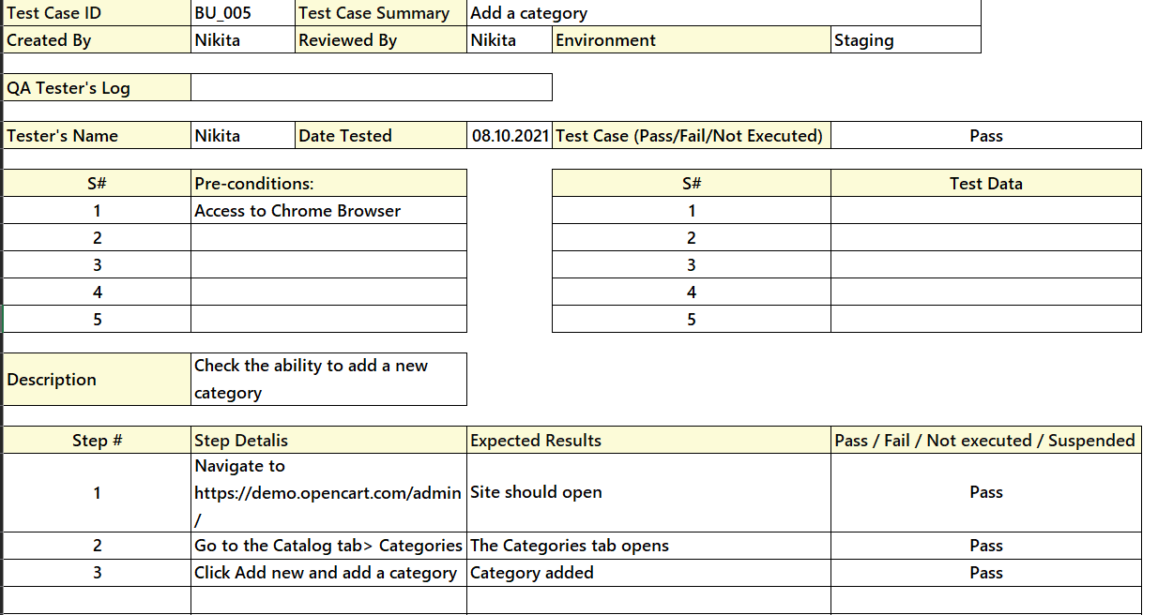

For the fifth test case, the design technique is causal. That is, when you enter data in the Categories tab (reason), a new category (consequence) is added.